**Menu**

**Day Clinic Service Booking**

1. Master
   1. Doctor Specialization Master
   2. Doctor Master
   3. Day Clinic-Doctor Mapping
   4. Day Clinic-Doctor Roster
   5. Doctor Consultation Charge Details
2. Transaction
3. Patient Appointment
4. Doctor Patient Appointment
5. Patient Visit
6. Patient Appointment Cancellation
7. Patient Treatment
8. Off-Line Patient Treatment Sheet Entry
9. On-Line Patient Treatment Sheet Entry
10. View
11. Day Clinic Roaster
12. Day Clinic Schedule (Day and time of opening and closing)
13. Day Clinic Wise Doctor Availability/ schedule (Day and time)
14. Day Clinic Wise Control
15. Day Clinic wise Doctor Wise patient booking
16. Day Clinic wise Doctor Wise patient visit
17. Day Clinic wise and Doctor wise appointment cancellation
18. Doctor Wise Control
19. Doctor Wise Day Clinic wise patient booking
20. Doctor Wise Day Clinic wise patient visit
21. Doctor wise Day Clinic wise appointment cancellation
22. Collection Analysis
23. Day Clinic wise and Date wise collection
24. Day Clinic wise monthly collection
25. Doctor Wise and Date wise collection
26. Doctor Wise monthly collection
27. Patient Category wise and Date wise Collection
28. Master View
29. Specialization wise List of Doctor

|  |  |  |  |
| --- | --- | --- | --- |
| **1** | **Master** | Sl. No. |  |
|  | Doctor Specialization Master | 1 | DAY_DOC_SPL |
|  | Doctor Master | 2 | DAY_DOC_MST |
|  | Day Clinic-Doctor Mapping | 3 | DAY_DOC_MAP |
|  | Day Clinic-Doctor Roster | 4 5 | DAY_DOC_RST  DAY_DOC_RST_DTL |
|  | Doctor Consultation Charge Details | 6 | DAY_DOC_RT_DTL |
|  |  |  |  |
| 2. | Transaction |  |  |
| 2.1 | Patient Appointment |  |  |
| 2.1.1 | Doctor Patient Appointment | 13 | DAY_DOC_PAT_BOOK |
| 2.1.2 | Patient Visit | 13 | DAY_DOC_PAT_BOOK |
| 2.1.3 | Patient Appointment Cancellation | 13 | DAY_DOC_PAT_BOOK |
|  |  |  |  |
| 2.2 | Patient Treatment |  |  |
| 2.2.1 | Off-Line Patient Treatment Sheet Entry | 13 | DAY_DOC_PAT_BOOK |
|  | * Observation Details | 7 | DAY_PAT_OBSER_DTL |
|  | * Investigation Details | 11 | DAY_PAT_TEST_DTL |
|  | * Operation Details | 12 | DAY_PAT_OPTN_DTL |
|  | * Medicine Details | 8 | DAY_PAT_MED_DTL |
|  | * Clinical Details | 10 | DAY_PAT_CLN_PROC_DT |
|  | * Advice Details | 9 | DAY_PAT_GENADV_DTL |
|  | * Follow up Check Details | 14 | DAY_PAT_FOLLOWUPCHK_DTL |
|  |  |  |  |
| 2.2.2 | On-Line Patient Treatment Sheet Entry | 13 | DAY_DOC_PAT_BOOK |
|  | * Observation Details | 7 | DAY_PAT_OBSER_DTL |
|  | * Investigation Details | 11 | DAY_PAT_TEST_DTL |
|  | * Operation Details | 12 | DAY_PAT_OPTN_DTL |
|  | * Medicine Details | 8 | DAY_PAT_MED_DTL |
|  | * Clinical Details | 10 | DAY_PAT_CLN_PROC_DT |
|  | * Advice Details | 9 | DAY_PAT_GENADV_DTL |
|  | * Follow up Check Details | 14 | DAY_PAT_FOLLOWUPCHK_DTL |
|  |  |  |  |

1. **Master**
   1. Doctor Specialization Master

**List Page**

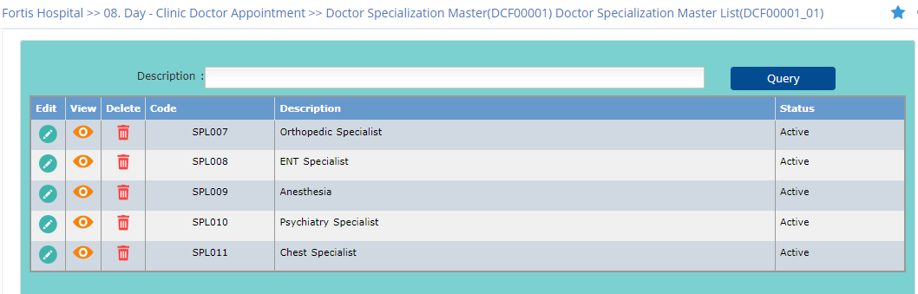

**Add Page**

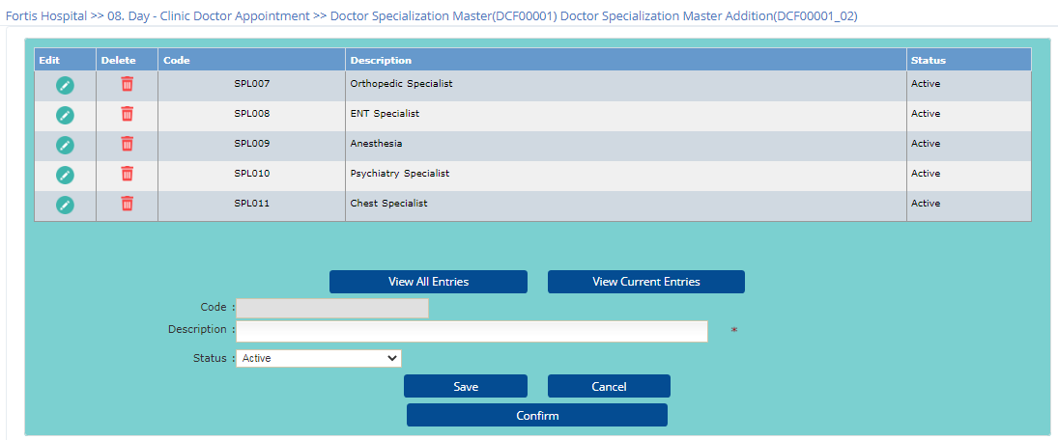

* 1. Doctor Master

**List Page**

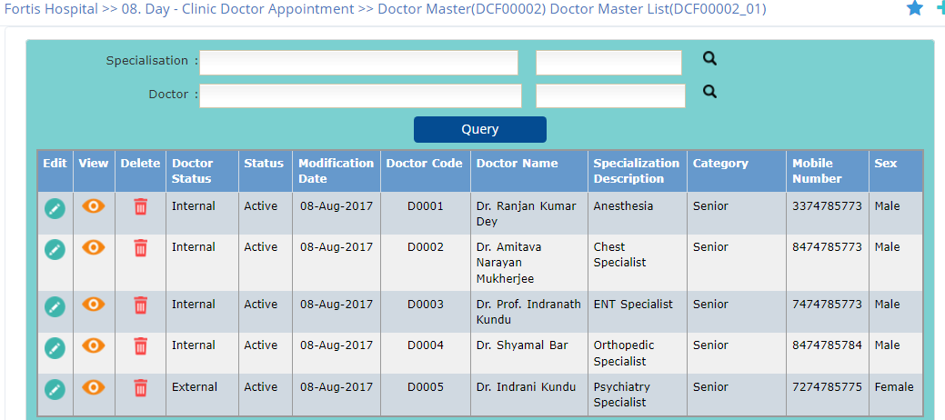

**Add Page**

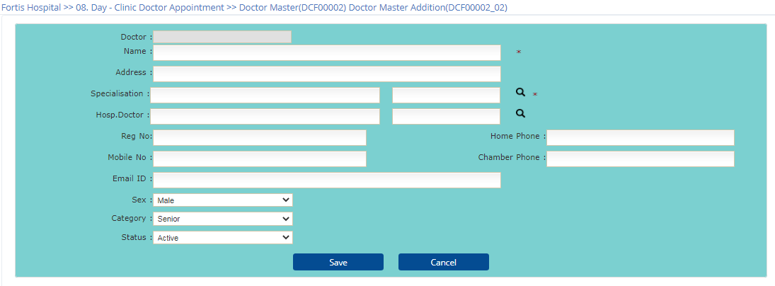

* 1. Day Clinic-Doctor Mapping

**List Page**

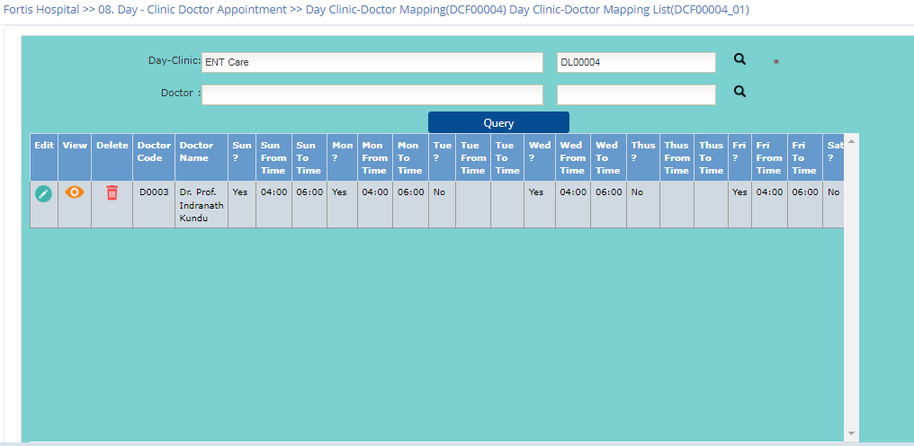

**Add Page** 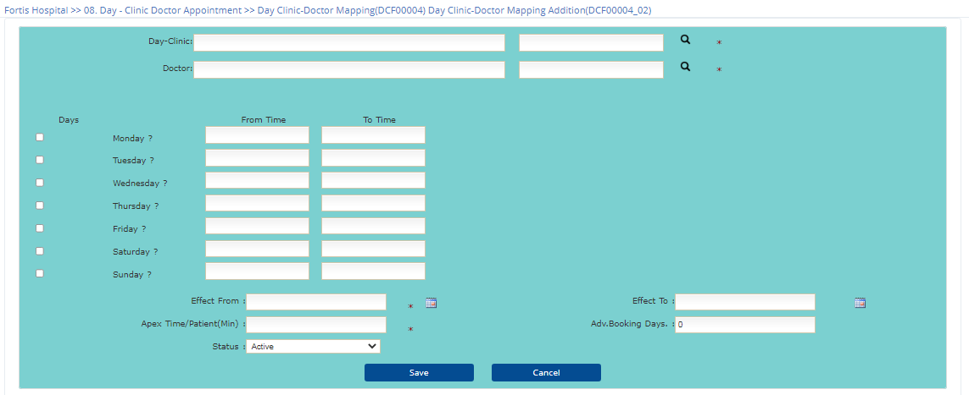

* 1. Day Clinic-Doctor Roster

**List Page**

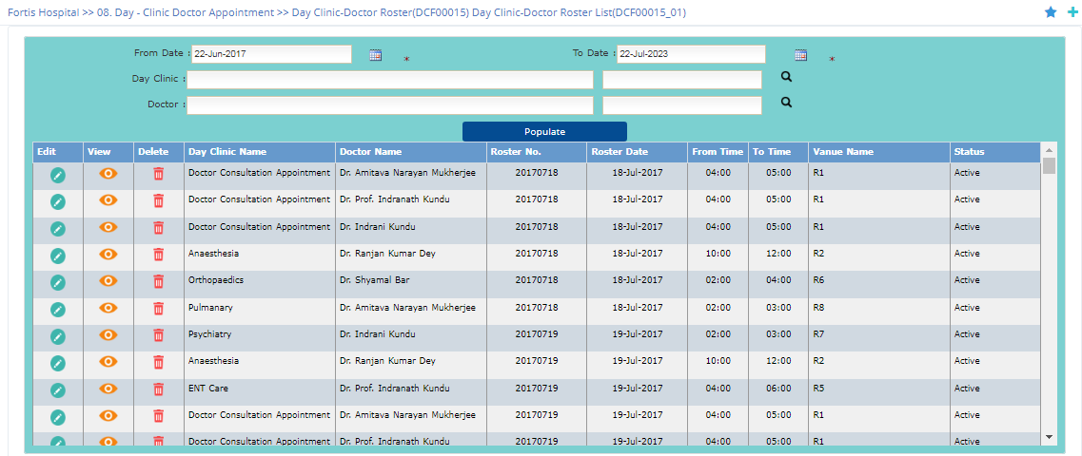

**Add Page**

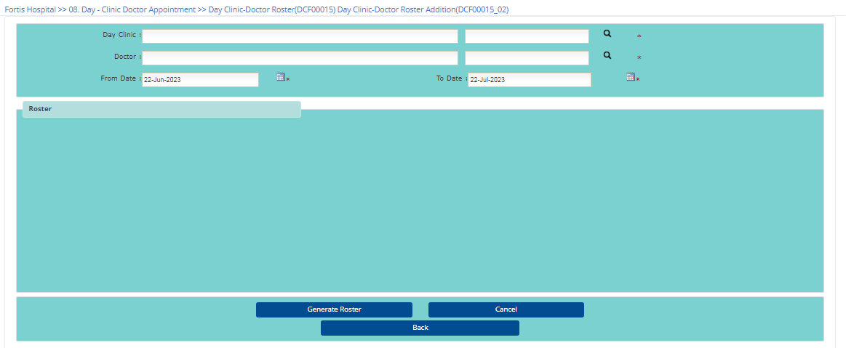

* 1. Doctor Consultation Charge Details

**List Page**

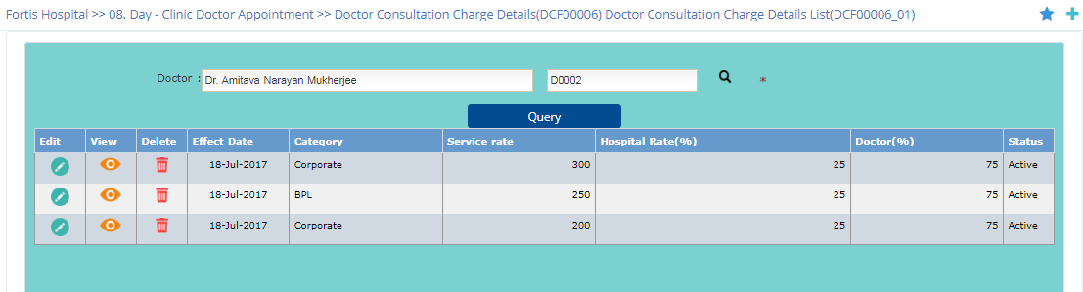

**Add Page**

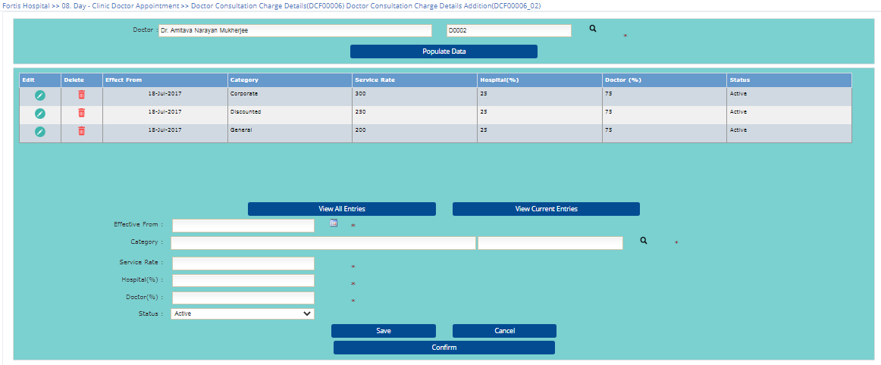

1. **Transaction**
2. Patient Appointment
   1. Doctor Patient Appointment

**List Page**

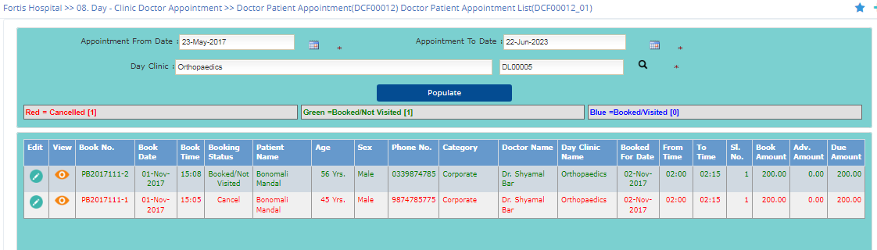

**Add Page**

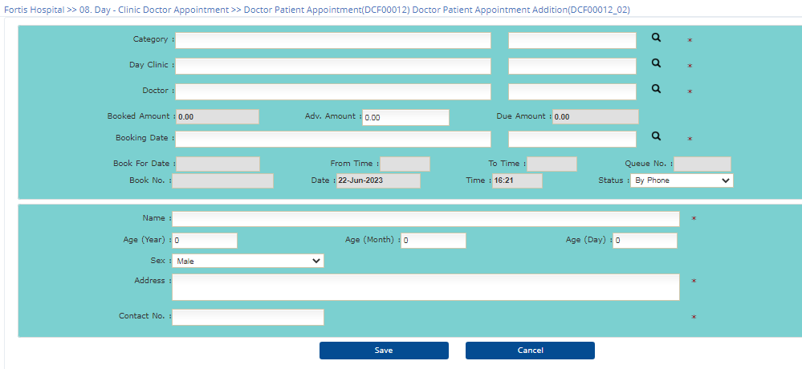

* 1. Patient Visit

**List Page**

|  |  |
| --- | --- |
|  |  |

**Add Page**

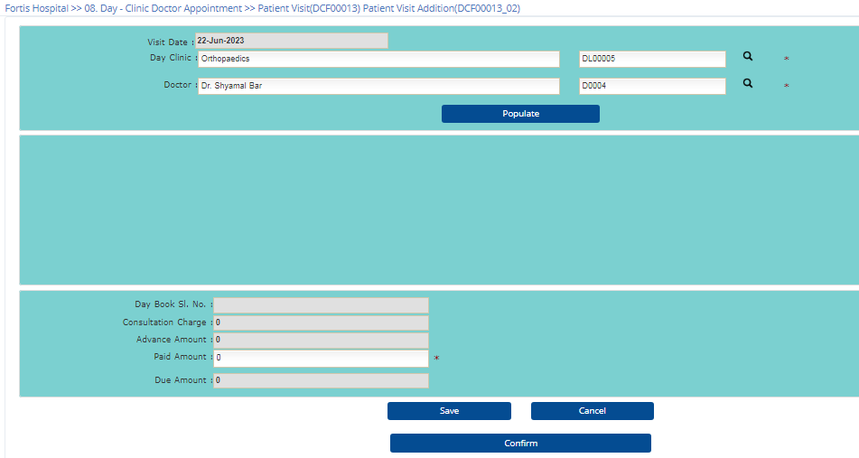

* 1. Patient Appointment Cancellation

**List Page**

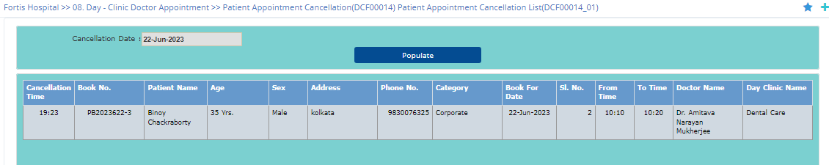

**Add Page**

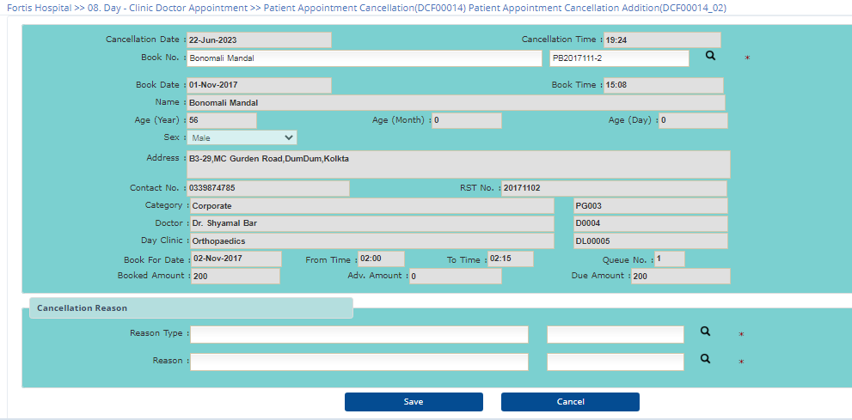

1. Patient Treatment
2. Off-Line Patient Treatment Sheet Entry

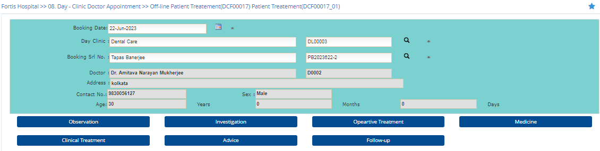

**Observation Details**

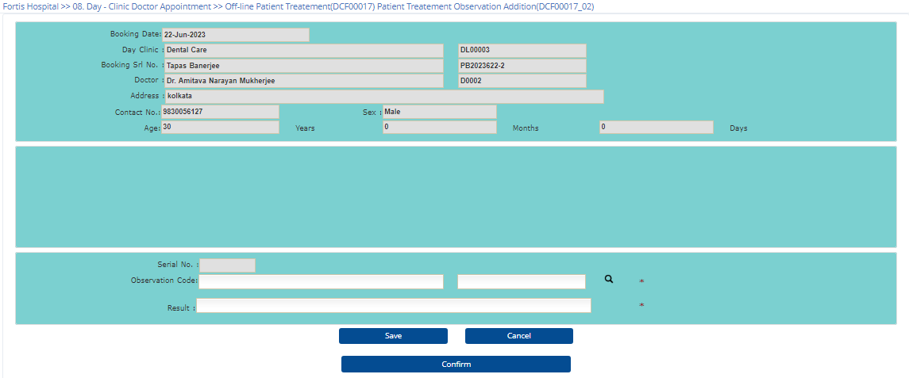

**Investigation Details**

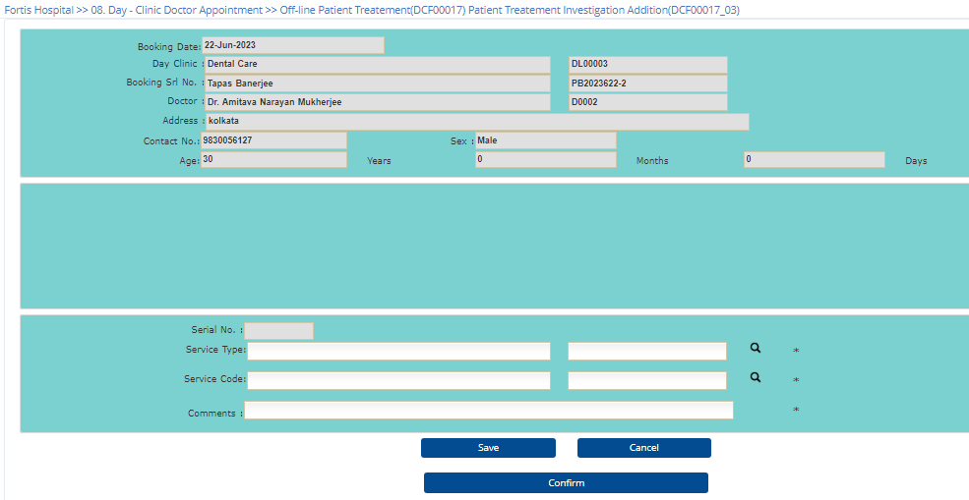

**Oparative Treatment Details**

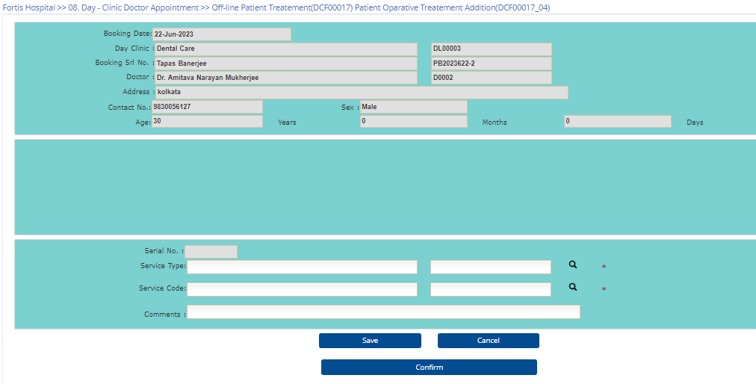

**Medicine Details**

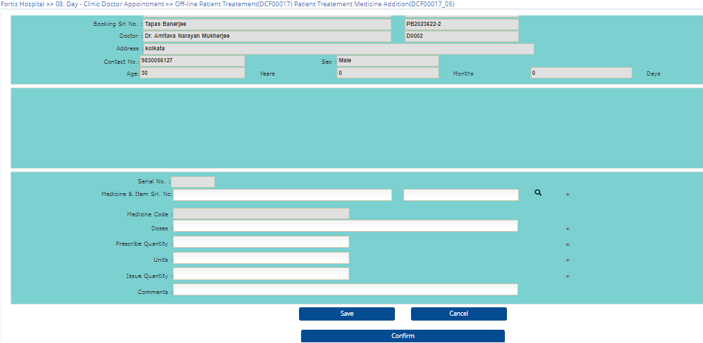

**Clinical Details**

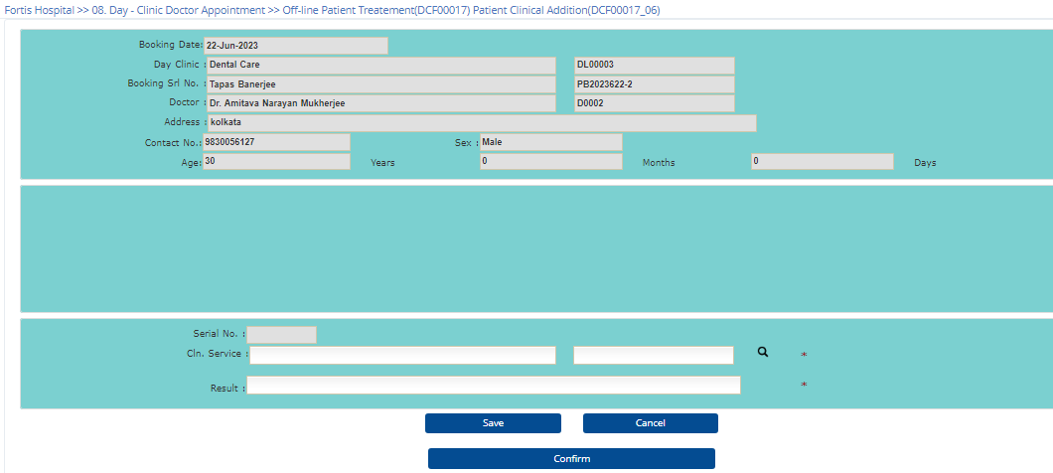

**Advice Details**

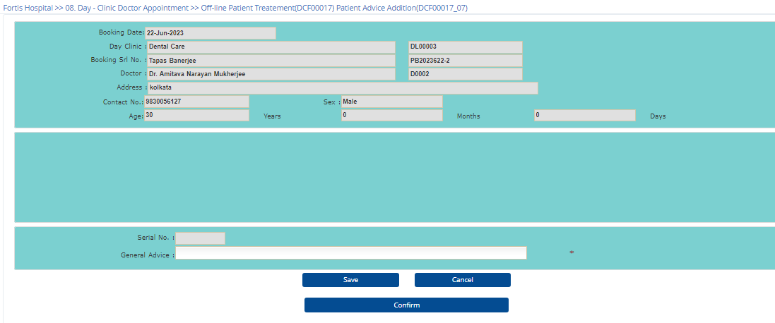

**Follow up Details**

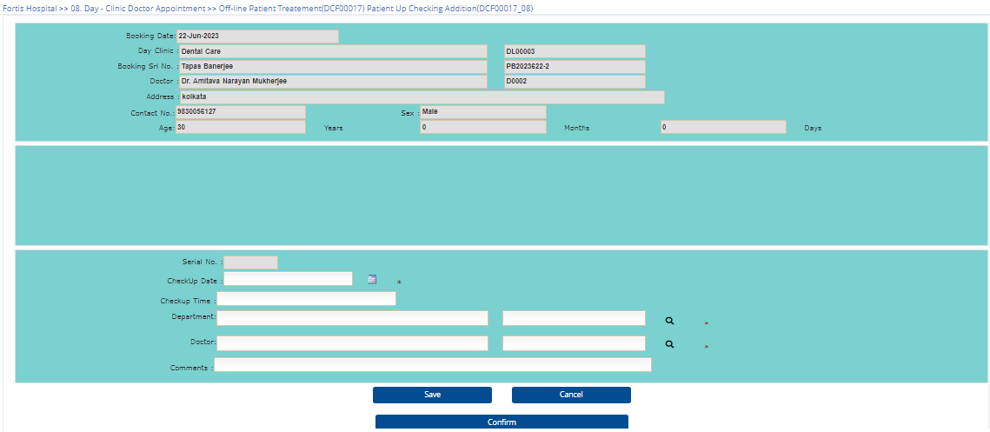

1. On-Line Patient Treatment Sheet Entry

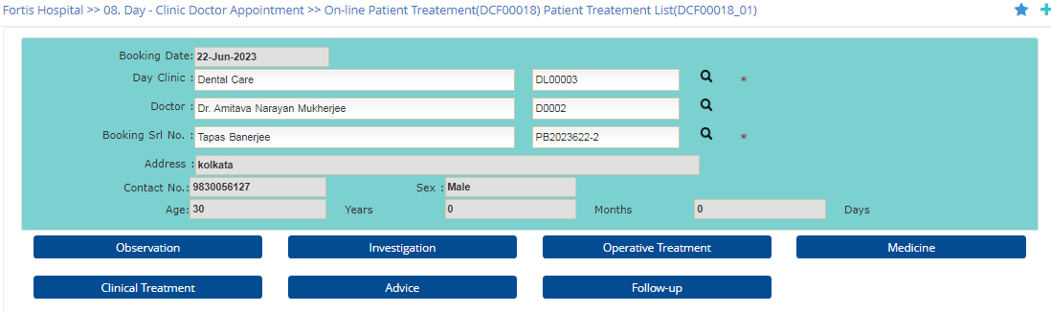

**Observation Details**

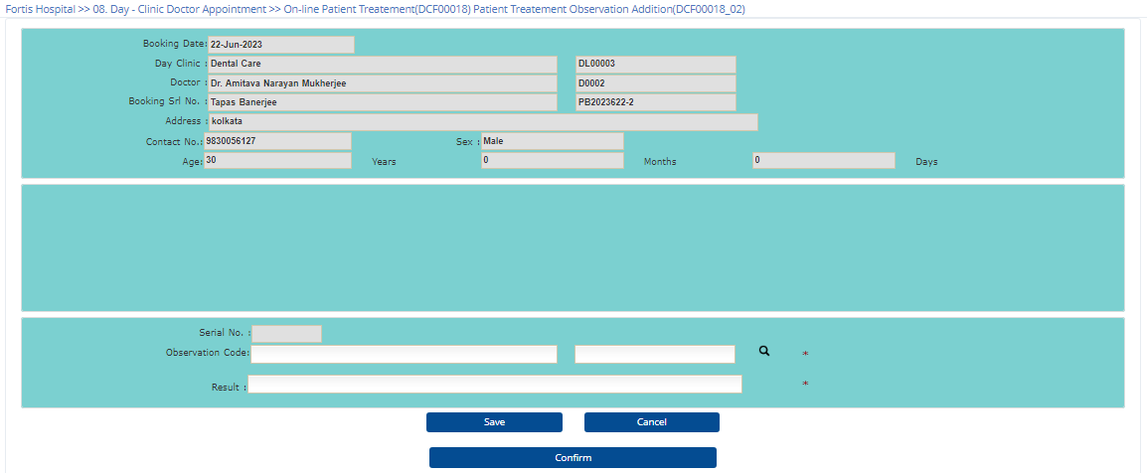

**Investigation Details**

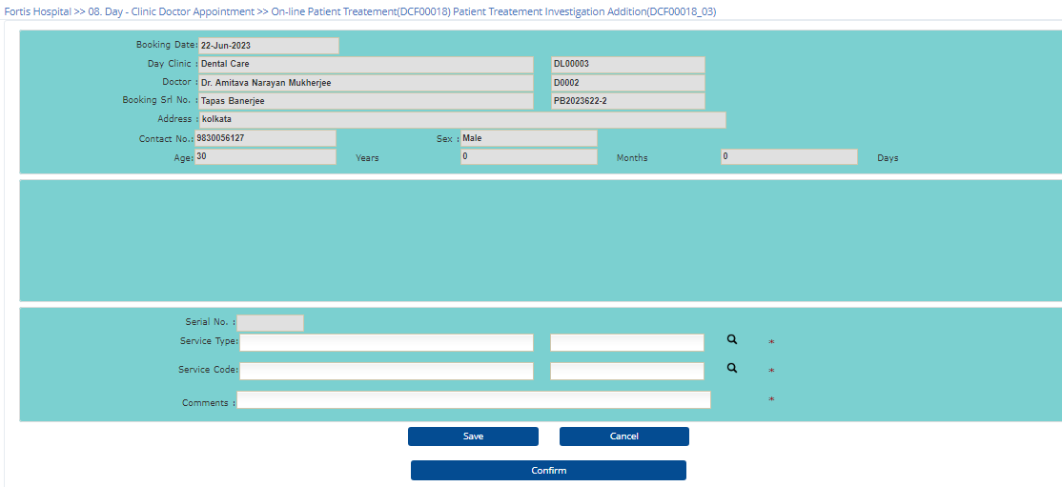

**Operative Treatment Details**

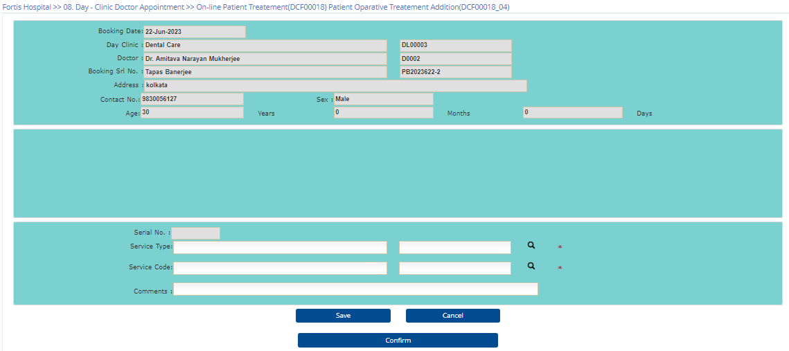

**Medicine Details**

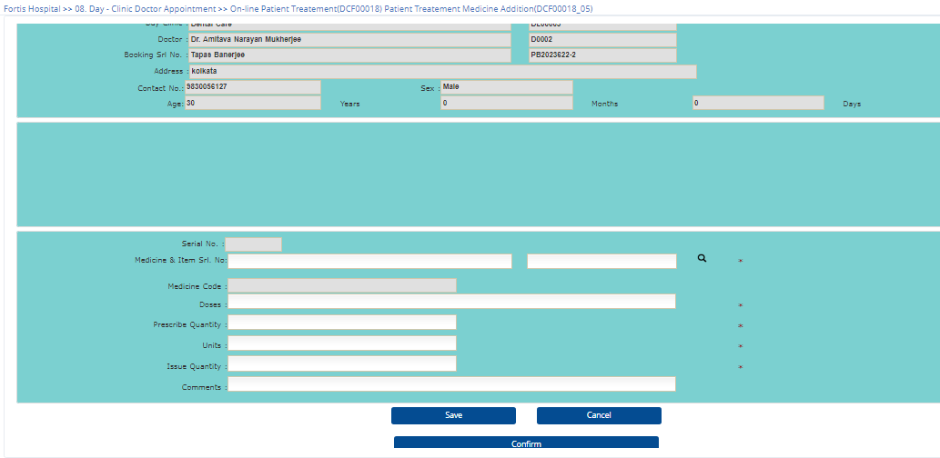

**Clinical Treatment Details**

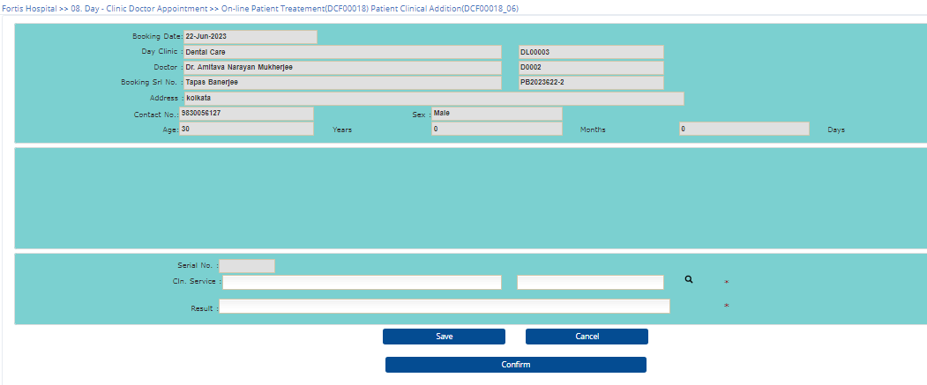

**Advice Details**

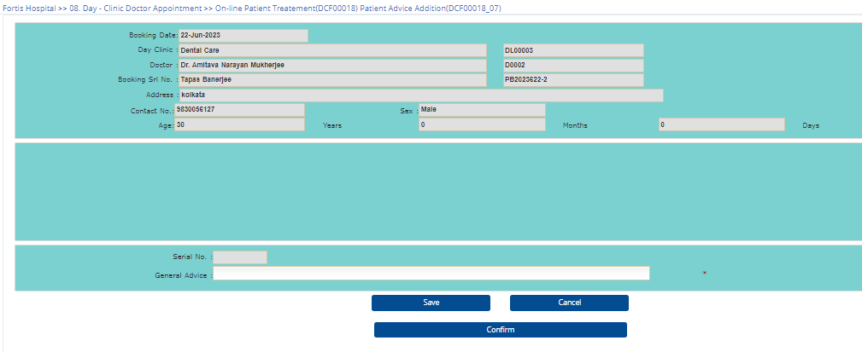

**Follow up Details**

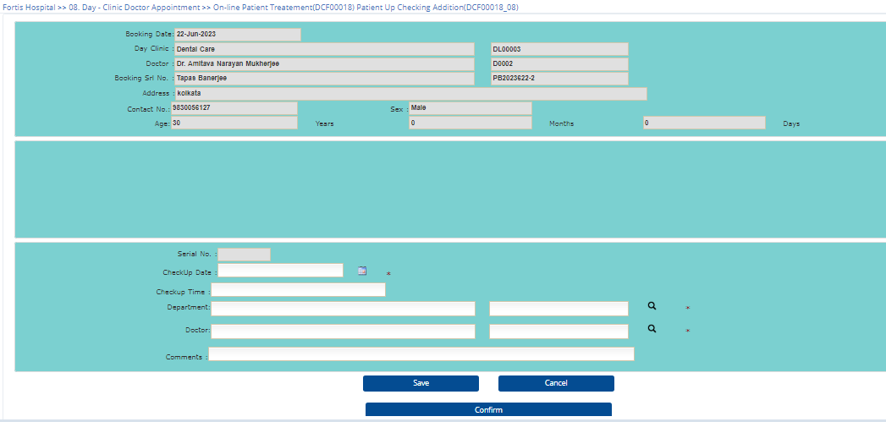

1. **View**
2. Day Clinic Roaster
3. Day Clinic Schedule (Day and time of opening and closing)

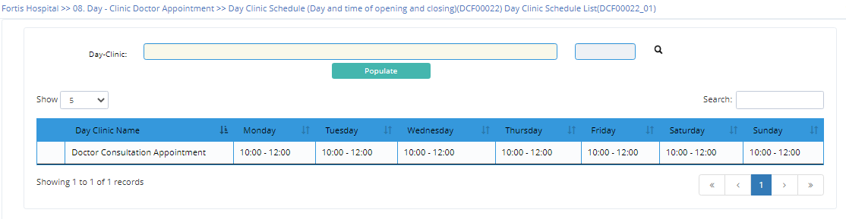

1. Day Clinic Wise Doctor Availability/ schedule (Day and time)

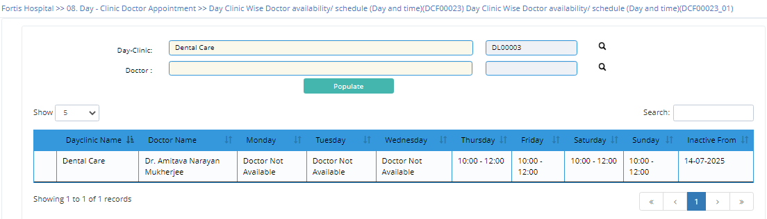

1. Day Clinic Wise Control
2. Day Clinic wise Doctor Wise patient booking
3. Day Clinic wise Doctor Wise patient visit

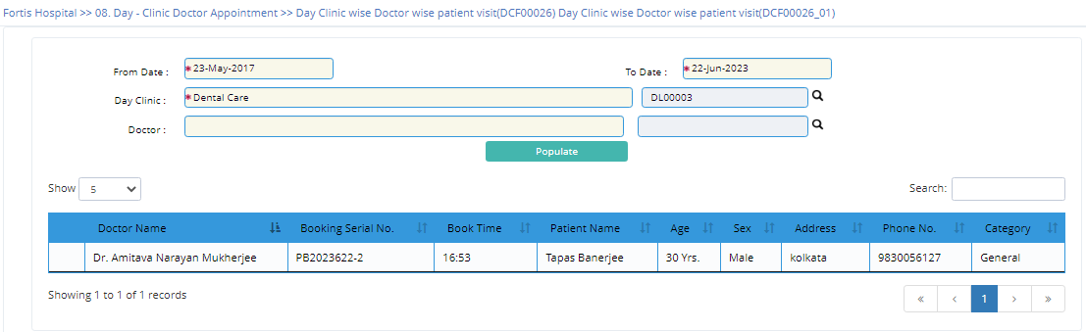

1. Day Clinic wise and Doctor wise appointment cancellation

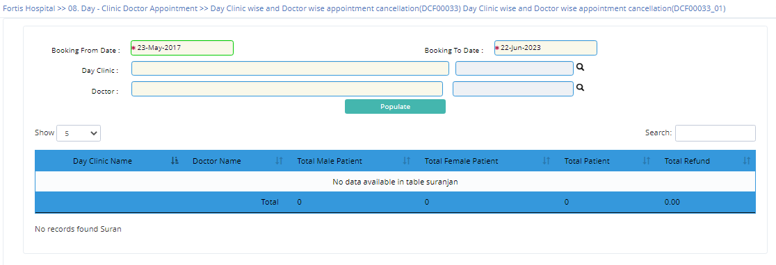

1. Doctor Wise Control
2. Doctor Wise Day Clinic wise patient booking

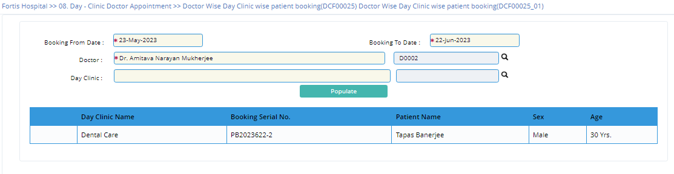

1. Doctor Wise Day Clinic wise patient visit

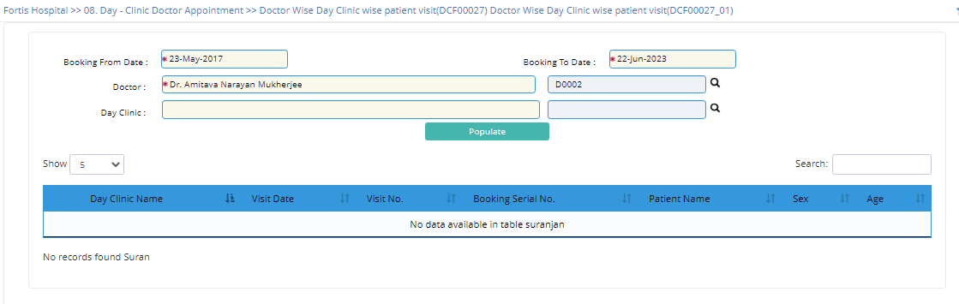

1. Doctor wise Day Clinic wise appointment cancellation

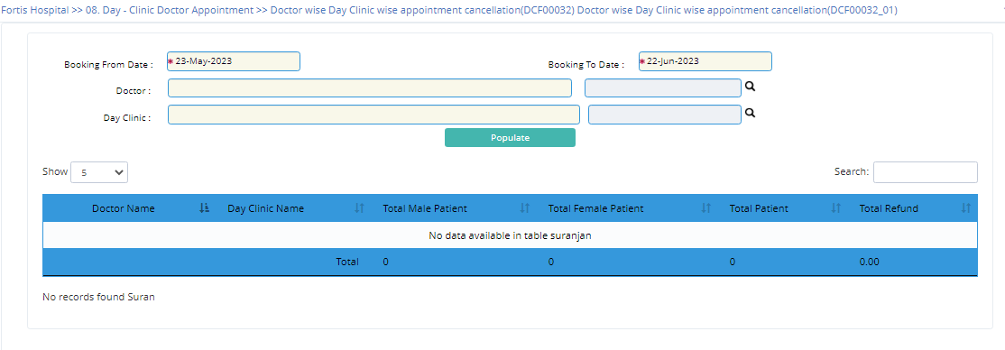

1. Collection Analysis
2. Day Clinic wise and Date wise collection

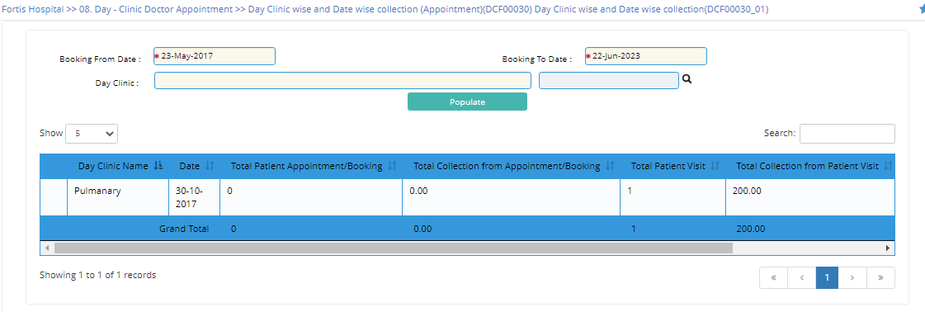

1. Day Clinic wise monthly collection

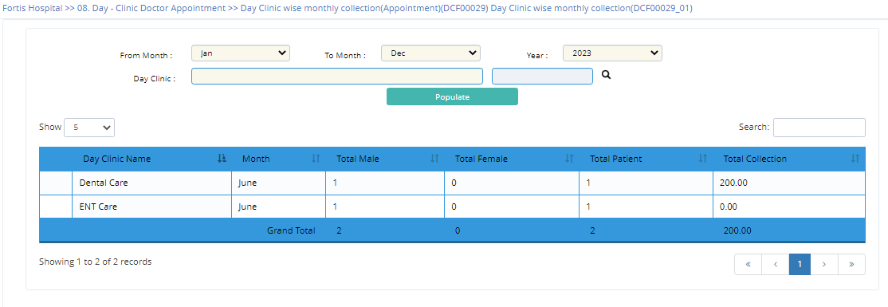

1. Doctor Wise and Date wise collection

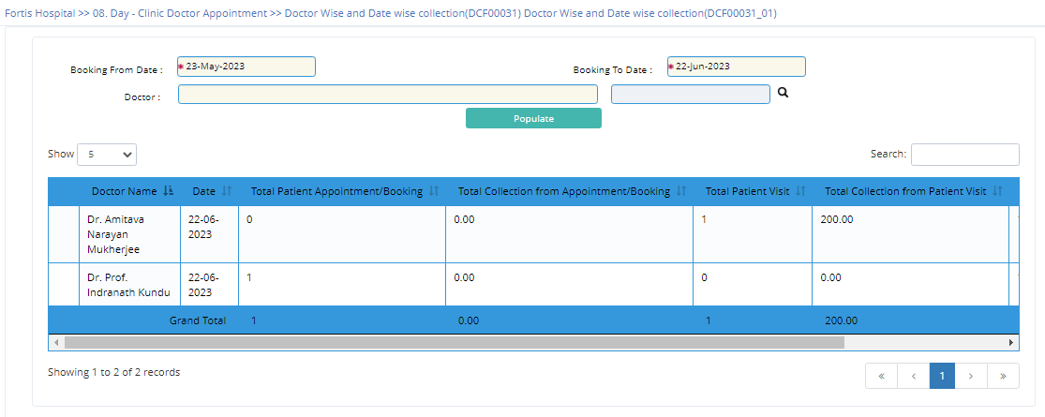

1. Doctor Wise monthly collection

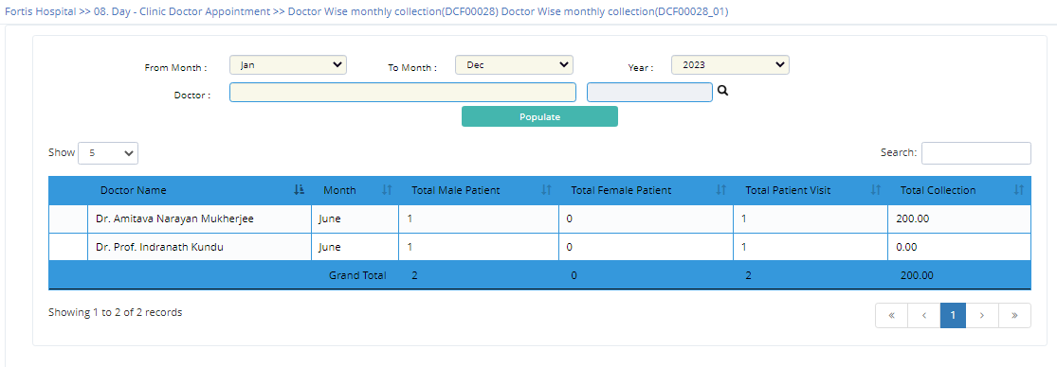

1. Patient Category wise and Date wise Collection

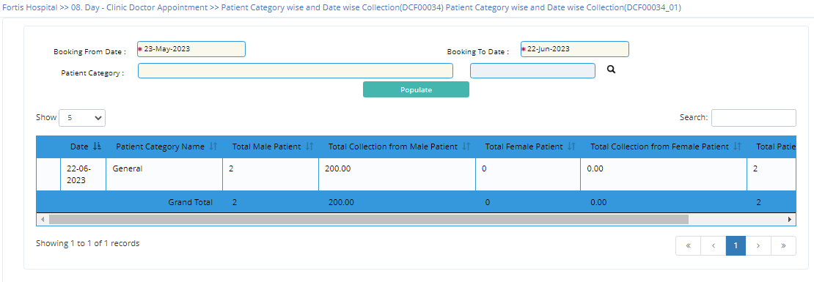

1. Master View
2. Specialization wise List of Doctor

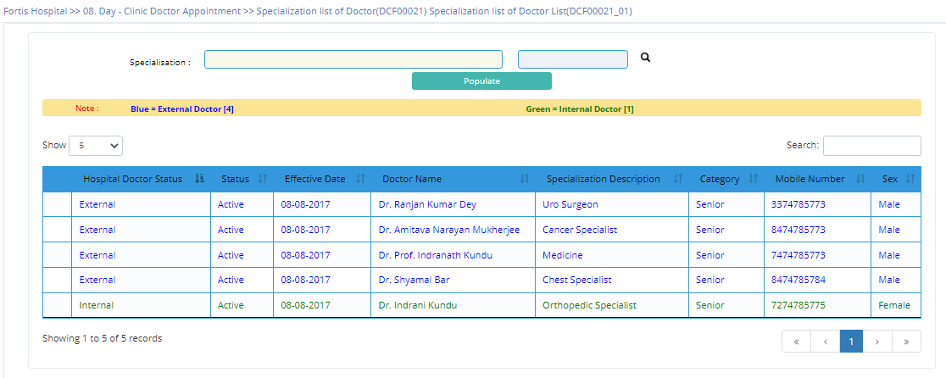

*****************************************************************************************************************************

No. : 1

Module Group : HMIS Web V2

Module : 105 Day-Clinic Appointment

Object Type : Table

Object : DAY_DOC_SPL

Description : Doctor Specialisation Master

File Name : M0236_0020

Object Category: Master Table

*****************************************************************************************************************************

Create Table DAY_DOC_SPL(

SPL_CD Text(10) Not Null , ' Special Code

SPL_DESC Text(50) Not Null , ' Specialisation Description

ACTIVE_FLG Text(1) Default 'Y' Not Null , ' Active Flag ([Y]es / [N]o)

ENTRY_DT Date(8) , ' Entry Date

USER_CD Text(10) , ' User Code

SESSION_ID Numeric(9) , ' Session Id

ACT_FLG Text(1) Default 'A' Not Null , ' Active Flag (Active-"A",Inactive-"I", Delete -"D")

MOD_DT Date(8) , ' Modification Date

SESSION_ID_WEB Text(30) , ' Session ID for Web Development

Constraint PK001_M0236_0020 Primary Key (SPL_CD),

Constraint CK001_M0236_0020 Check Key (ACTIVE_FLG ('Y','N'),

Constraint CK002_M0236_0020 Check Key (ACT_FLG) ('A','I','D')

);

*****************************************************************************************************************************

No. : 2

Module Group : HMIS Web V2

Module : 105 Day-Clinic Appointment

Object Type : Table

Object : DAY_DOC_MST

Description : Doctor Master

File Name : M0236_0021

Object Category: Master Table

*****************************************************************************************************************************

Create Table DAY_DOC_MST(

HOS_CD Text(10) Not Null , ' Hospital Code

DOC_CD Text(10) Not Null , ' Doctor Code

DOC_NM Text(50) Not Null , ' Name of the Doctor

ADDRESS Text(100) , ' Address

SEX Text(1) Default M Not Null , ' Sex ([M]ale/[F]emale)

SPL_CD Text(10) Not Null , ' Special Code

RES_PH Text(12) , ' Residential Phone

CHAMBER_PH Text(12) , ' Chamber Phone No.

MOBILE_NO Text(15) , ' Mobile No.

EMAIL_ID Text(20) , ' Email ID

REGI_NO Text(25) , ' Registration No.

GRADE_FLG Text(1) Default 'S' Not Null , ' Grade Flag [S]enior / [J]unior

HOS_DOC_FLG Text(1) Default 'N' Not Null , ' Hosp. Doctor Flag (Yes/No)

REF_DOC_CD Text(10) , ' Ref. Doctor Code

ACTIVE_FLG Text(1) Default Y Not Null , ' Active Flag ([Y]es / [N]o)

REMARKS Text(100) , ' Remarks

PRL_EMP_CD Text(22) , ' Payroll Employee Code

ENTRY_DT Date(8) , ' Entry Date

USER_CD Text(10) , ' User Code

SESSION_ID Numeric(9) , ' Session Id

ACT_FLG Text(1) Default 'A' Not Null , ' Active Flag (Active-"A",Inactive-"I", Delete -"D")

MOD_DT Date(8) , ' Modification Date

SESSION_ID_WEB Text(30) Not Null , ' Session ID for Web Development

Constraint PK001_M0236_0021 Primary Key (HOS_CD,DOC_CD),

Constraint CK003_M0236_0021 Check Key (ACT_FLG ('A','I','D'),

Constraint CK001_M0236_0021 Check Key (ACTIVE_FLG ('Y','N'),

Constraint CK002_M0236_0021 Check Key (SEX) ('M','F')

);

*****************************************************************************************************************************

No. : 3

Module Group : HMIS Web V2

Module : 105 Day-Clinic Appointment

Object Type : Table

Object : DAY_DOC_MAP

Description : Day Clinic Doctor Mapping

File Name : M0236_0022

Object Category: Master Table

*****************************************************************************************************************************

Create Table DAY_DOC_MAP(

HOS_CD Text(10) Not Null , ' Hospital Code

DAY_CLINIC_CD Text(10) Not Null , ' Day Clinic Code

DOC_CD Text(10) Not Null , ' Doctor Code

SUN_FLG Text(1) Default 'N' Not Null , ' Sunday Flag (Yes/No)

MON_FLG Text(1) Default 'N' Not Null , ' Monday Flag (Yes/No)

TUE_FLG Text(1) Default 'N' Not Null , ' Tuesday Flag (Yes/No)

WED_FLG Text(1) Default 'N' Not Null , ' Wednesday Flag (Yes/No)

THU_FLG Text(1) Default 'N' Not Null , ' Thursday Flag (Yes/No)

FRI_FLG Text(1) Default 'N' Not Null , ' Friday Flag (Yes/No)

SAT_FLG Text(1) Default 'N' Not Null , ' Saterday Flag (Yes/No)

SUN_FR_TM Text(5) Not Null , ' Sunday From Time

SUN_TO_TM Text(5) Not Null , ' Sunday To Time

MON_FR_TM Text(5) Not Null , ' Monday From Time

MON_TO_TM Text(5) Not Null , ' Monday To Time

TUE_FR_TM Text(5) Not Null , ' Tuesday From Time

TUE_TO_TM Text(5) Not Null , ' Tuesday Flag

WED_FR_TM Text(5) Not Null , ' Wednesday From Time

WED_TO_TM Text(5) Not Null , ' Wednesday To Time

THU_FR_TM Text(5) Not Null , ' Thrusday From Time

THU_TO_TM Text(5) Not Null , ' Thursday To Time

FRI_FR_TM Text(5) Not Null , ' Friday From Time

FRI_TO_TM Text(5) Not Null , ' Friday To Time

SAT_FR_TM Text(5) Not Null , ' Saturday From Time

SAT_TO_TM Text(5) Not Null , ' Saterday To Time

EFFECT_FROM Date(8) Not Null , ' Effective From

EFFECT_TO Date(8) , ' Effect To

APPX_REQ_TM Text(5) Not Null , ' Approx. Required Time

ADV_DAY Numeric(9) Default 0 Not Null , ' Advance Booking Allow Upto Days

ACTIVE_FLG Text(1) Default 'Y' Not Null , ' Active Flag ([Y]es / [N]o)

ENTRY_DT Date(8) Not Null , ' Entry Date

USER_CD Text(10) Not Null , ' User Code

SESSION_ID Numeric(9) Default 0 Not Null , ' Current User Session

ACT_FLG Text(1) Default 'A' Not Null , ' Active Flag (Active-"A",Inactive-"I", Delete -"D")

MOD_DT Date(8) , ' Modification Date

SESSION_ID_WEB Text(30) , ' Session ID for Web Development

Constraint PK001_M0236_0022 Primary Key (HOS_CD,DAY_CLINIC_CD,DOC_CD),

Constraint CK001_M0236_0022 Check Key (ACTIVE_FLG ('Y','N'),

Constraint CK002_M0236_0022 Check Key (ACT_FLG) ('A','I','D')

);

*****************************************************************************************************************************

No. : 4

Module Group : HMIS Web V2

Module : 105 Day-Clinic Appointment

Object Type : Table

Object : DAY_DOC_RST

Description : Day Clinic Doctor Roster

File Name : M0236_0023

Object Category: Master Table

*****************************************************************************************************************************

Create Table DAY_DOC_RST(

HOS_CD Text(10) Not Null , ' Hospital Code

DAY_CLINIC_CD Text(10) Not Null , ' Day Clinic Code

RST_NO Text(10) Not Null , ' Roster No.

DOC_CD Text(10) Not Null , ' Doctor Code

RST_DT Date(8) Not Null , ' Roster Date

FROM_TM Text(5) Not Null , ' From Time

TO_TM Text(5) Not Null , ' To Time

VENUE_NM Text(50) Not Null , ' Venue Name

ACTIVE_FLG Text(1) Default 'Y' Not Null , ' Active Flag ([Y]es / [N]o)

ENTRY_DT Date(8) Not Null , ' Entry Date

USER_CD Text(10) Not Null , ' User Code

SESSION_ID Numeric(9) Default 0 Not Null , ' Session Id

ACT_FLG Text(1) Default 'A' Not Null , ' Active Flag (Active-"A",Inactive-"I", Delete -"D")

MOD_DT Date(8) , ' Modification Date

Constraint PK001_M0236_0023 Primary Key (HOS_CD,DAY_CLINIC_CD,RST_NO,DOC_CD),

Constraint CK001_M0236_0023 Check Key (ACTIVE_FLG ('Y','N'),

Constraint CK002_M0236_0023 Check Key (ACT_FLG) ('A','I','D')

);

*****************************************************************************************************************************

No. : 5

Module Group : HMIS Web V2

Module : 105 Day-Clinic Appointment

Object Type : Table

Object : DAY_DOC_RST_DTL

Description : Day Clinic Doctor Roster

File Name : M0236_0024

Object Category: Master Table

*****************************************************************************************************************************

Create Table DAY_DOC_RST_DTL(

HOS_CD Text(10) Not Null , ' Hospital Code

DAY_CLINIC_CD Text(10) Not Null , ' Day Clinic Code

RST_NO Text(10) Not Null , ' Roster No.

DOC_CD Text(10) Not Null , ' Doctor Code

QUE_NO Text(9) Default 0 Not Null , ' Queue No.

FROM_TM Text(5) Not Null , ' From Time

TO_TM Text(5) Not Null , ' To Time

BOOK_FLG Text(1) Default 'N' Not Null , ' Booking Flag ([Y]es /[N]o)

DAY_BOOK_SL_NO Text(20) , ' Day Booking Serial No.

SRL_NO Numeric(9) Default 0 Not Null , ' Srl. No.

ACTIVE_FLG Text(1) Default 'Y' Not Null , ' Active Flag ([Y]es / [N]o)

ENTRY_DT Date(8) Not Null , ' Entry Date

USER_CD Text(10) Not Null , ' User Code

SESSION_ID Numeric(9) Default 0 Not Null , ' Session Id

ACT_FLG Text(1) Default 'A' Not Null , ' Active Flag (Active-"A",Inactive-"I", Delete -"D")

MOD_DT Date(8) , ' Modification Date

Constraint PK001_M0236_0024 Primary Key (HOS_CD,DAY_CLINIC_CD,RST_NO,DOC_CD,QUE_NO),

Constraint CK001_M0236_0024 Check Key (ACTIVE_FLG ('Y','N'),

Constraint CK002_M0236_0024 Check Key (ACT_FLG) ('A','I','D')

);

*****************************************************************************************************************************

No. : 6

Module Group : HMIS Web V2

Module : 105 Day-Clinic Appointment

Object Type : Table

Object : DAY_DOC_RT_DTL

Description : Doctor Consultaton Charge Details

File Name : M0236_0025

Object Category: Master Table

*****************************************************************************************************************************

Create Table DAY_DOC_RT_DTL(

HOS_CD Text(10) Not Null , ' Hospital Code

DOC_CD Text(10) Not Null , ' Doctor Code

EFF_DT Date(8) Not Null , ' The date from which user account will be ac

' tive

CAT_CD Text(10) Not Null , ' Category Code

SERV_AMT Float(8) Not Null , ' Service Amount

HOS_PER Float(8) Default 0 Not Null , ' Hospital Percentage

DOC_PER Float(8) Default 0 Not Null , ' Doctor Percentage

ENTRY_DT Date(8) Not Null , ' Entry Date

ACTIVE_FLG Text(1) Default 'Y' Not Null , ' Active Flag ([Y]es / [N]o)

USER_CD Text(10) Not Null , ' User Code

SESSION_ID Numeric(9) Default 0 Not Null , ' Session Id

ACT_FLG Text(1) Default 'A' Not Null , ' Active Flag (Active-"A",Inactive-"I", Delete -"D")

MOD_DT Date(8) , ' Modification Date

SESSION_ID_WEB Text(30) Not Null , ' Session ID for Web Development

Constraint PK001_M0236_0025 Primary Key (HOS_CD,DOC_CD,EFF_DT,CAT_CD),

Constraint CK001_M0236_0025 Check Key (ACTIVE_FLG ('Y','N'),

Constraint CK002_M0236_0025 Check Key (ACT_FLG) ('A','I','D')

);

*****************************************************************************************************************************

No. : 7

Module Group : HMIS Web V2

Module : 105 Day-Clinic Appointment

Object Type : Table

Object : DAY_PAT_OBSER_DTL

Description : Patient Observation Details

File Name : M0236_0028

Object Category: Details Table

*****************************************************************************************************************************

Create Table DAY_PAT_OBSER_DTL(

HOS_CD Text(10) Not Null , ' Hospital Code

DAY_BOOK_SL_NO Text(20) Not Null , ' Day Booking Serial No.

SL_NO Numeric(9) Not Null , ' Serial No

OBSER_CD Text(10) Not Null , ' Observation Code

RESULT Text(50) , ' Result

ACT_FLG Text(1) Default 'A' Not Null , ' Active Flag (Active-"A",Inactive-"I", Delete -"D")

MOD_DT Date(8) , ' Modification Date

Constraint PK001_M0236_0028 Primary Key (HOS_CD,DAY_BOOK_SL_NO,SL_NO),

Constraint FK001_M0236_0028 Foreign Key (HOS_CD,DAY_BOOK_SL_NO) References (DAY_DOC_PAT_BOOK) (HOS_CD,DAY_BOOK_SL_NO) ,

Constraint CK001_M0236_0028 Check Key (ACT_FLG) ('A,'I','D')

);

*****************************************************************************************************************************

No. : 8

Module Group : HMIS Web V2

Module : 105 Day-Clinic Appointment

Object Type : Table

Object : DAY_PAT_MED_DTL

Description : Patient Medicine Details

File Name : M0236_0029

Object Category: Details Table

*****************************************************************************************************************************

Create Table DAY_PAT_MED_DTL(

HOS_CD Text(10) Not Null , ' Hospital Code

DAY_BOOK_SL_NO Text(20) Not Null , ' Day Booking Serial No.

SL_NO Numeric(9) Not Null , ' Serial No

ITEM_CAT_CD Text(20) , ' Item Category Code

DOSE_DTL Text(20) , ' Dose Details

PRES_QTY Float(8) Default 0 Not Null , ' Prescribe Quantity

UNITS Text(15) , ' Units

ISU_QTY Float(8) Default 0 Not Null , ' Issue Quantity

COMM Text(50) , ' Comments

SRL_NO Numeric(9) , ' Serial No

ACT_FLG Text(1) Default 'A' Not Null , ' Active Flag (Active-"A",Inactive-"I", Delete -"D")

MOD_DT Date(8) , ' Modification Date

Constraint PK001_M0236_0029 Primary Key (HOS_CD,DAY_BOOK_SL_NO,SL_NO),

Constraint FK001_M0236_0029 Foreign Key (HOS_CD,DAY_BOOK_SL_NO) References (DAY_DOC_PAT_BOOK) (HOS_CD,DAY_BOOK_SL_NO) ,

Constraint CK001_M0236_0029 Check Key (ACT_FLG) ('A','I','D')

);

*****************************************************************************************************************************

No. : 9

Module Group : HMIS Web V2

Module : 105 Day-Clinic Appointment

Object Type : Table

Object : DAY_PAT_GENADV_DTL

Description : Patient Genaral Advice Details

File Name : M0236_0030

Object Category: Details Table

*****************************************************************************************************************************

Create Table DAY_PAT_GENADV_DTL(

HOS_CD Text(10) Not Null , ' Hospital Code

DAY_BOOK_SL_NO Text(20) Not Null , ' Day Booking Serial No.

SL_NO Numeric(9) Not Null , ' Serial No

GEN_ADV Text(50) , ' General advice

ACT_FLG Text(1) Default 'A' Not Null , ' Active Flag (Active-"A",Inactive-"I", Delete -"D")

MOD_DT Date(8) , ' Modification Date

Constraint PK001_M0236_0030 Primary Key (HOS_CD,DAY_BOOK_SL_NO,SL_NO),

Constraint FK001_M0236_0030 Foreign Key (HOS_CD,DAY_BOOK_SL_NO) References (DAY_DOC_PAT_BOOK) (HOS_CD,DAY_BOOK_SL_NO) ,

Constraint CK001_M0236_0030 Check Key (ACT_FLG) ('A','I','D')

);

*****************************************************************************************************************************

No. : 10

Module Group : HMIS Web V2

Module : 105 Day-Clinic Appointment

Object Type : Table

Object : DAY_PAT_CLN_PROC_DTL

Description : Patients Clinical Procedure Details

File Name : M0236_0032

Object Category: Details Table

*****************************************************************************************************************************

Create Table DAY_PAT_CLN_PROC_DTL(

HOS_CD Text(10) Not Null , ' Hospital Code

DAY_BOOK_SL_NO Text(20) Not Null , ' Day Booking Serial No.

SL_NO Numeric(9) Not Null , ' Serial No

CLN_SERV_CD Text(10) Not Null , ' Clinical Service Code

RESULT Text(50) , ' Result

ACT_FLG Text(1) Default 'A' Not Null , ' Active Flag (Active-"A",Inactive-"I", Delete -"D")

MOD_DT Date(8) , ' Modification Date

Constraint PK001_M0236_0032 Primary Key (HOS_CD,DAY_BOOK_SL_NO,SL_NO),

Constraint FK001_M0236_0032 Foreign Key (HOS_CD,DAY_BOOK_SL_NO) References (DAY_DOC_PAT_BOOK) (HOS_CD,DAY_BOOK_SL_NO) ,

Constraint CK001_M0236_0032 Check Key (ACT_FLG) ('A','I','D')

);

*****************************************************************************************************************************

No. : 11

Module Group : HMIS Web V2

Module : 105 Day-Clinic Appointment

Object Type : Table

Object : DAY_PAT_TEST_DTL

Description : Patient Test Detail

File Name : M0236_0034

Object Category: Details Table

*****************************************************************************************************************************

Create Table DAY_PAT_TEST_DTL(

HOS_CD Text(10) Not Null , ' Hospital Code

DAY_BOOK_SL_NO Text(20) Not Null , ' Day Booking Serial No.

SL_NO Numeric(9) Not Null , ' Serial No

SERV_TYP Text(3) Not Null , ' Service Type

SERV_CD Text(7) Not Null , ' Service Code

COMM Text(50) , ' Comments

ACT_FLG Text(1) Default 'A' Not Null , ' Active Flag (Active-"A",Inactive-"I", Delete -"D")

MOD_DT Date(8) , ' Modification Date

Constraint PK001_M0236_0034 Primary Key (HOS_CD,DAY_BOOK_SL_NO,SL_NO),

Constraint FK001_M0236_0034 Foreign Key (HOS_CD,DAY_BOOK_SL_NO) References (DAY_DOC_PAT_BOOK) (HOS_CD,DAY_BOOK_SL_NO) ,

Constraint CK001_M0236_0034 Check Key (ACT_FLG) ('A','I','D')

);

*****************************************************************************************************************************

No. : 12

Module Group : HMIS Web V2

Module : 105 Day-Clinic Appointment

Object Type : Table

Object : DAY_PAT_OPTN_DTL

Description : Patient Surgical Detail

File Name : M0236_0035

Object Category: Details Table

*****************************************************************************************************************************

Create Table DAY_PAT_OPTN_DTL(

HOS_CD Text(10) Not Null , ' Hospital Code

DAY_BOOK_SL_NO Text(20) Not Null , ' Day Booking Serial No.

SL_NO Numeric(9) Not Null , ' Serial No

SERV_TYP Text(3) Not Null , ' Service Type

SERV_CD Text(7) Not Null , ' Service Code

OPTN_CD Text(10) , ' Operation Code

COMM Text(50) , ' Comments

ACT_FLG Text(1) Default 'A' Not Null , ' Active Flag (Active-"A",Inactive-"I", Delete -"D")

MOD_DT Date(8) , ' Modification Date

Constraint PK001_M0236_0035 Primary Key (HOS_CD,DAY_BOOK_SL_NO,SL_NO),

Constraint FK001_M0236_0035 Foreign Key (HOS_CD,DAY_BOOK_SL_NO) References (DAY_DOC_PAT_BOOK) (HOS_CD,DAY_BOOK_SL_NO) ,

Constraint CK001_M0236_0035 Check Key (ACT_FLG) ('A','I','D')

);

*****************************************************************************************************************************

No. : 13

Module Group : HMIS Web V2

Module : 105 Day-Clinic Appointment

Object Type : Table

Object : DAY_DOC_PAT_BOOK

Description : Day Clinic Doctor Patient Booking

File Name : M0236_0026

Object Category: Master Table

*****************************************************************************************************************************

Create Table DAY_DOC_PAT_BOOK(

HOS_CD Text(10) Not Null , ' Hospital Code

DAY_BOOK_SL_NO Text(20) Not Null , ' Day Booking Serial No.

BOOK_DT Date(8) Not Null , ' Booking Date

BOOK_TM Text(5) Not Null , ' Booking Time

PAT_NM Text(60) Not Null , ' Name of the Patient

AGE_YR Numeric(9) Default 0 , ' Age Year

AGE_MON Numeric(9) Default 0 , ' Age Month

AGE_DAY Numeric(9) , ' Age Day

SEX Text(1) Default 'M' Not Null , ' Sex ([M]ale/[F]emale)

PAT_ADD Text(200) Not Null , ' Address of the Patient

CONTACT_NO Text(20) Not Null , ' Contact No.

PAT_CAT Text(10) Not Null , ' Patient Category

DOC_CD Text(10) Not Null , ' Doctor Code

DAY_CLINIC_CD Text(10) Not Null , ' Day Clinic Code

BOOK_FOR_DT Date(8) Not Null , ' Book For Date

RST_NO Text(10) , ' Roster No.

BOOK_FR_TM Text(5) Not Null , ' Booking From Time

BOOK_TO_TM Text(5) Not Null , ' Booking To Time

QUE_NO Text(9) Default 0 Not Null , ' Queue No.

BOOK_STAT Text(1) Default 'P' Not Null , ' Book Status(P-Phone, V-Visit)

TOT_BOOK_AMT Float(8) Not Null , ' Total Booking Amount

ADV_AMT Float(8) Default 0 Not Null , ' Advanced Amount

PAID_AMT Float(8) Default 0 Not Null , ' Paid amount

DUE_AMT Float(8) Default 0 Not Null , ' Due amount

CAN_AMT Float(8) Default 0 Not Null , ' Cancel Amount

REFUND_AMT Float(8) Default 0 Not Null , ' Refund Amount

BOOK_CANCEL_FLG Text(1) Default 'N' Not Null , ' Booking Cancel Flag (Y/N)

BOOK_CNCL_ENTRY_DT Date(8) , ' Cancellation Entry Date

BOOK_CNCL_TM Text(5) , ' Book Cancel Time

CNCL_RSN_TYP_CD Text(5) , ' Cancellation Reason Type Code

BOOK_CAN_RSN_CD Text(5) , ' Book Cancellation Reason Code

BOOK_CAN_USER_CD Text(10) , ' Booking Cancel User Code

BOOK_CAN_SESSION_ID Numeric(9) , ' Booking Cancel Session ID

REPORTING_FLG Text(1) Default 'N' Not Null , ' Reporting Flag ([Y]es /[N]o)

REPORTING_DT Date(8) , ' Patient Reporting Date

REPORTING_TM Text(5) , ' Patient Reporting Time

RPT_USER_CD Text(10) , ' Reporting User Code

RPT_SESSION_ID Numeric(9) , ' Reporting Session Id.

VISIT_FLG Text(1) Default 'N' Not Null , ' Visit Flag (Yes/No)

REFUND_FLG Text(1) Default 'N' Not Null , ' Refund Flag [Y]es/[N]o

ENTRY_DT Date(8) Not Null , ' Entry Date

USER_CD Text(10) Not Null , ' User Code

SESSION_ID Numeric(9) Default 0 Not Null , ' Session Id

ACT_FLG Text(1) Default 'A' Not Null , ' Active Flag (Active-"A",Inactive-"I", Delete -"D")

MOD_DT Date(8) , ' Modification Date

SESSION_ID_WEB Text(30) , ' Session ID for Web Development

Constraint PK001_M0236_0026 Primary Key (HOS_CD,DAY_BOOK_SL_NO),

Constraint CK005_M0236_0026 Check Key (REPORTING_FLG ('Y','N'),

Constraint CK006_M0236_0026 Check Key (ACT_FLG ('A','I','D'),

Constraint CK001_M0236_0026 Check Key (VISIT_FLG ('Y','N'),

Constraint CK002_M0236_0026 Check Key (REFUND_FLG ('Y','N'),

Constraint CK003_M0236_0026 Check Key (SEX ('M','F'),

Constraint CK004_M0236_0026 Check Key (BOOK_CANCEL_FLG) ('Y','N')

);

*****************************************************************************************************************************

No. : 14

Module Group : HMIS Web V2

Module : 105 Day-Clinic Appointment

Object Type : Table

Object : DAY_PAT_FOLLOWUPCHK_DTL

Description : Day Clinic Followup Check Details

File Name : M0236_0036

Object Category: Details Table

*****************************************************************************************************************************

Create Table DAY_PAT_FOLLOWUPCHK_DTL(

HOS_CD Text(10) Not Null , ' Hospital Code

DAY_BOOK_SL_NO Text(20) Not Null , ' Day Booking Serial No.

SL_NO Numeric18,0 Not Null , ' Serial No.

CHK_DT Date(8) , ' Check Det

CHK_TM Text(5) , ' Checking Time

CHK_DEPT Text(10) , ' Checking Depertment

DOC_CD Text(10) , ' Doctor Code

COMM Text(50) , ' Comments

ACT_FLG Text(1) Default 'A' Not Null , ' A=Active , I=In Active, D=Deleted

MOD_DT Date(8) , ' Last Modified Date & Time

Constraint PK001_M0236_0036 Primary Key (HOS_CD,DAY_BOOK_SL_NO,SL_NO),

Constraint CK001_M0236_0036 Check Key (ACT_FLG) ('A','D','I')

);